System design : Facebook News Feed

HLD : It is science behind creating system that can scale

Below are the first thing we need to do when we do System Design

1. List out the Features : which is highly important
2. Estimate the Scale : at which the load, user, hit etc
3. Trade off [Imp.] : what do you need to focus on more on, and what you can do compromise
4. Arch. Design : Which can support all the above three things

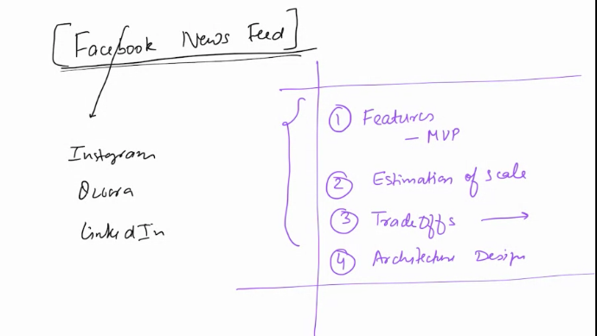

1. Features: [Highlighted points are the MVP : Mon. Vibal Product] [Must Have feature]

a. Able to view the collection of post [relevant post]
b. We should allow Like, Comment, Share
c. Multi media support: User can post image, Video, text
d. Relevant Post based on friends, followers, connection strength [if i like more post/comments/share]
e. Time Decay : We should see the post which is post recently and old post may be see or not see
f. Cut-off : If a post is deleted, or mark as Inactive then it should not be visible.
g. Search A Post
h. Made a Post
i. News Feed Should be automatically soft refreshed [Feed Section will be refreshed]
j. Pagination and Page should also be lazy refreshed
k. Popular post

2. Estimate the Scale: [Very Important]

Don’t be perfect But scale with some common sense.

No. of User of FB : 2B
Daily Active Users on FB : 2B*10% = 200M

But, How many users Post in a Day : ??

No. of People who make at least 1 post : 200M * 20% = 40M

Avg. Posts/user/post = 2

no. of new post/days = 40M*2 = 80M or 100M [We can assume]

Now Lets talk about what all post can contains :
a. Text = 100 chars [avg. Size of post] = 100Bytes
b. Image(s) : Media Content : we will store this as fileStorage [or blob storage] [Will not store in DB]
c. Video(s) : Media Content : we will store this as fileStorage [Will not store in DB]
d. URL(s) :
e. timestamp,
f. user id
g. params

Overall we can assume one Post can have 300 Bytes

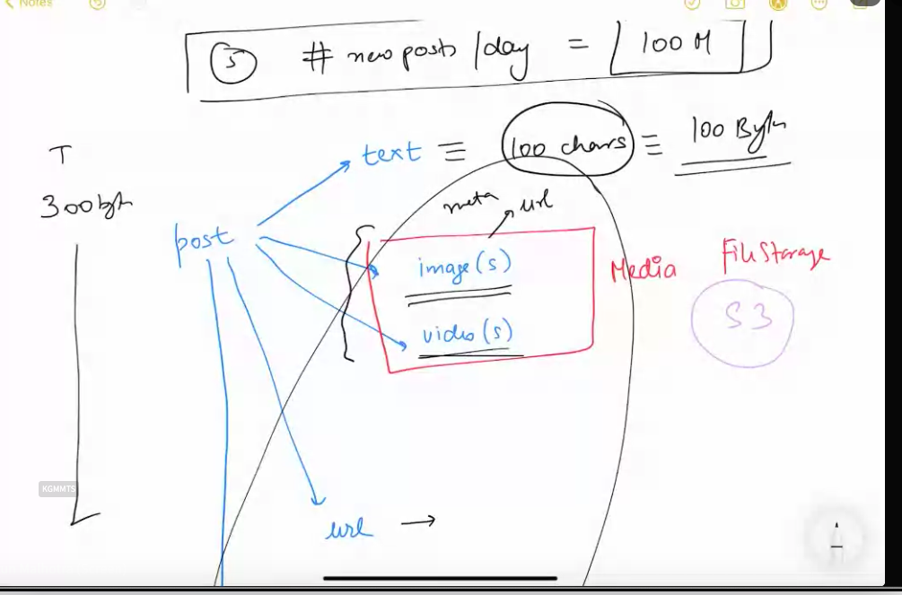

Storage Requirement per day = no. Of post in a day * size of one post = 100 M * 300 byte = 30GB

Storage for 10 years = 30GB * 10* 365 =~ 100TB

If 1 Machine storage is = 2TB
We will required = Min. 50 Machine

Load factor = 60% – 75%

Machine required actually = 50/0.6 = 80 machine

Re

Write Calculation

Post = Write

no. of write/day = 100M/day

Read Cal. :

no. of Read/day = write/day * factor

or

no. of Read/day = no. Of daily active users * avg. no. Of time user make request for new feed

= 200M * 50 = 10,000M = 10B read/day

Read QPS = 10B/(24*60*60) = 115K QPS [Every Sec. FB will rec. Read request]

Write QPS = 100 M / (24*60*60) = ~1000 QPS

